Part 1: Results from Activity 6

In 150-250 words, discuss which environment had the greatest richness based on your class data and the analysis of your lab instructor. You should justify your answer using descriptive statistics and the results of the statistical test. You can comment if you notice any differences in species composition and/or evidence for selection pressures between the environments.

Part II: Endosymbiosis and reading scientific literature: Background
This is an introduction to scientific literature. You should read your assigned article (Paramecium OR Tetrahymena) and the textbook (pages 559-581 - Chapter 24) and discuss how endosymbiosis could be an adaptive advantage for a unicellular organism, citing the article and the text where appropriate. You should use a result from the paper and an example protist from the textbook to support your argument (maximum of 400 words). Note that it is not necessary to deeply understand the paper to do the assignment, but to have a working knowledge of one of the results.

Experiment:
You will be using your compound microscope to view slides from the different environments in a similar manner to activity 4. Remember that an extensive description of the parts of the microscope, further details on its use, and how to calibrate it are outlined in Appendix A. You will be able to measure specimens using this information. You will make slides from the lab cultures, as directed by your Lab Instructor and following the procedure that you used in activity 4. Using the microscope, you will count the number of different organisms that you see under one field of view at your 10X objective on each slide with the remainder of the lab time, using the following key to identify protists you observe. Most organisms are unicellular, although some form colonies and a few are considered simple multicellular organisms (Reece et al. 2011). You can use the dichotomous key following to determine which organism you have - you can also check with your Lab Instructor. It is okay to do a best guess today as we are looking at the number of different species, not for a particular species. You should record the group, genus or species name, supergroup, domain and number of each that you see on the worksheet at the end.

Rubric:
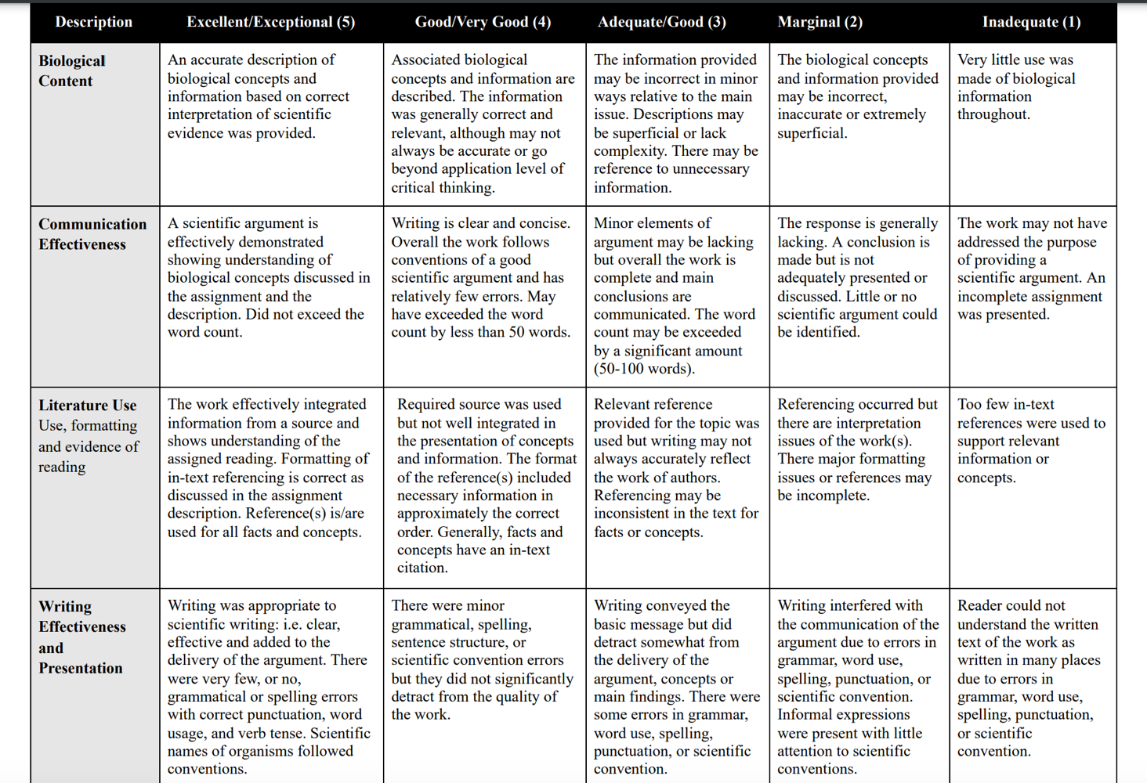

My Data:
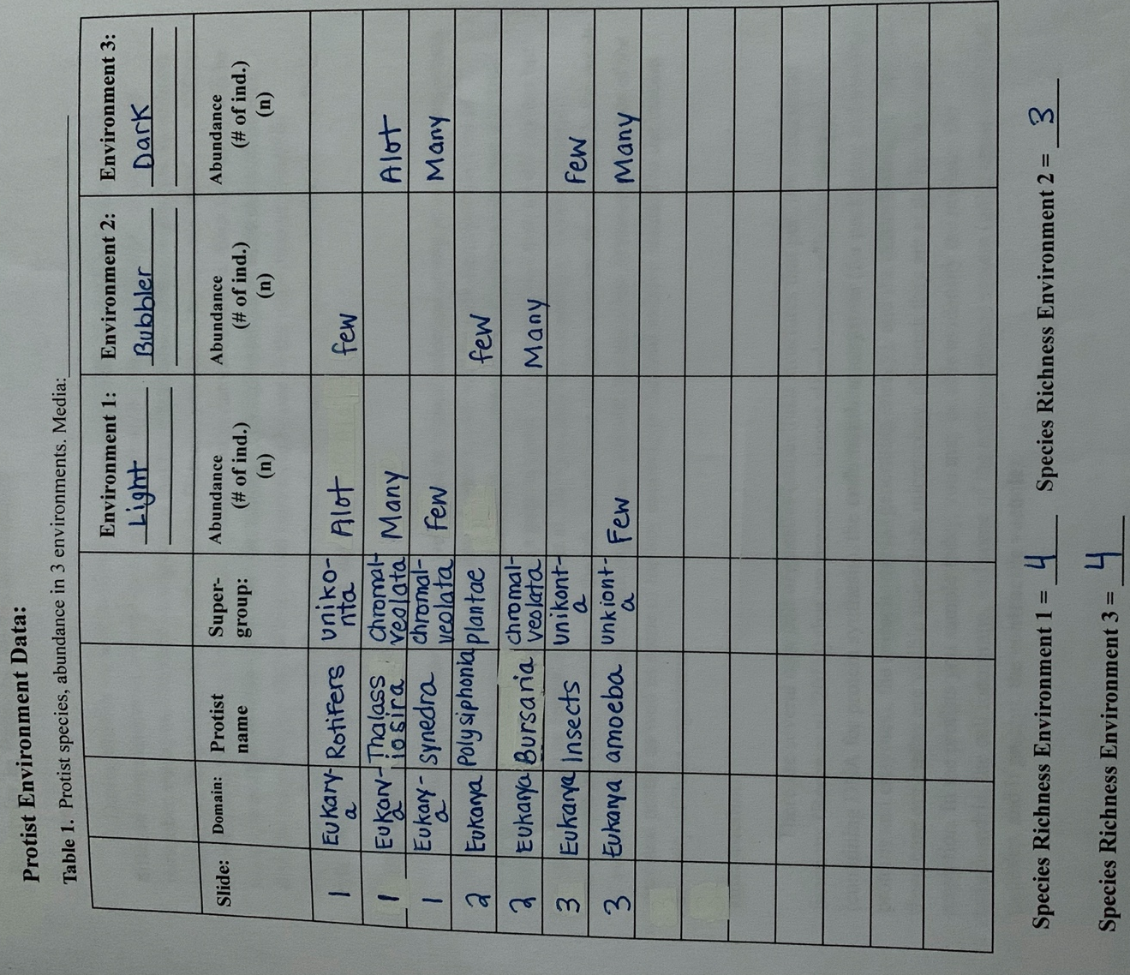
Class Data: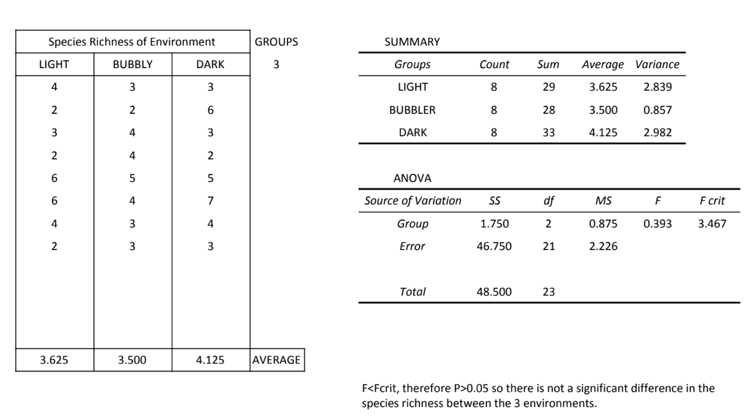

Link for question 2:
https://learn.macewan.ca/bbcswebdav/pid-2872292-dt-content-rid-21500014_1/courses/BIOL_108_Labs_Merged_2020_FA/Iwai_et_al-2435-Paramecium%20endosymbionts.pdf

